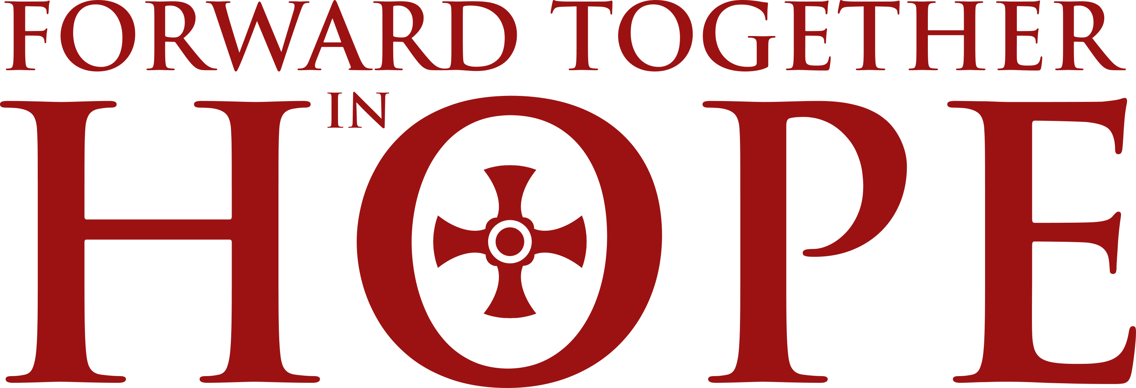

Feedback from Representatives’ Meeting
11 July 2015
St Robert’s Parish Hall, Fenham

- Leaves on the Forward Together in Hope tree
Participants were asked to write on ‘leaves’ their hopes for Forward Together in Hope and exchange these with others before adding them to the bare tree. The hopes expressed are set out below.

I hope Forward Together in Hope will….
- Reach out to those marginalised in the parish and church.
- Bring more people in the parish into active involvement.
- Give us some good ideas to take back to the parish.
- Bring more involvement of lay people in parish life.
- Move our church from maintenance to mission.
- Bring lasting cooperation between parishes.
- Enhance unity even to the north of the county.
- Ignite hope for real change in the Church.
- Help us to attune to God’s will not ours.
- Inspire people to share their strengths.
- Give some guidance on the practice so far.
- Make people more active in the community.
- Enliven the faith of the few to share with the many.
- Encourage laity to take part in parish life to the full.
- The Diocese will move forward and all work together.
- Start and end with a conscious loving union with God.
- Help us to deepen our love for the treasure of our faith.
- Give us the opportunity to be more open to change.
- Help us all be more joyful and courageous about our faith.
- Open our communities to sharing with others the love of Jesus.
- Provide a basis for the development of the Diocese for several years.
- Encourage parishioners to become more involved in the church community as the changes take place.
- Result in many more young Catholics staying the course from 1st Holy Communion to Confirmation.
- I hope Forward Together in Hope will…Is the beginning of an era of real respect for laity involvement and use of their many gifts.

- Encourage people to feel able to participate more in the life of their parish. Improve communication between people of various ages.

- Bring strength and spiritual enlightenment to those who feel afraid of change.
- Help me to grow in faith and enable someone else to through my actions.
- Allow parishes to upload answers early rather than a last minute rush.
- Stimulate, rejuvenate, reactive our parish priest / congregation and Diocese.

- Result in greater openness among clergy to the vocations of the laity.
- Increase vocations to the priesthood and involve more lay people.
- Somehow encourage the young Catholic community to flourish and grow.
I hope
Forward Together in Hope will….

- Encourage more parishioners to come forward to share talent.
- Enrich my parish life.
- Bring closer links between the parish and the chaplaincy.
- Build and strengthen the Church’s future in the Diocese.
- Regenerate my parish.
- Enliven my parish and help young people.
- Give community a sense of ownership.
- Raise awareness of need for change.
- Engage with the wider community.
- Get our priests free to do what is important.
- Do what it said – encourage people in discipleship rather than simply “move people in the pews”.
- Enable parishioners to realise that they can do great things to move forward our faith.
- Bring our communities together to work for the Kingdom of God.
- Bring members of our parish closer together in a love of God.
- Unite our parish into an active community.
- Understand why so many people have stopped attending church.
- Help our parish become more of a community.
- Help us to go forward, strengthening our faith.
- Bear fruit for the whole Diocese in the long term.
- Bring a future in the Church for all my children.
- Become a reality for everyone in the Diocese.
- Have more interaction with other parishes.
- Promote a deeper spiritualisation in the Diocese.
- Bring about a way to engage more young people in our church.
- Enliven us to think about the future and what our church really means to us.
- Turn clergy and readers into excellent communicators.
I hope
Forward Together in Hope will….
- Bring out the talents of many people.
- Give us the guidance to know how to proceed further.
- Encourage parishioners they are part of the FTiH process, not just the priest and committee.
- Have support needed by clergy.
- Bring more young people to church. Bring more men into priesthood. Help the young understand God’s teachings.

- Open the eyes of older parishioners who won’t let go of the reigns to realise the future of the parish is safe in the hands of younger people.

- Make our parish “friends” of other faiths more important in our lives.
- Unburden priests from lots of tasks which people can be trained in and empowered.
- Open the Church as an institution to new ways of being church and disciples, including looking at what is meant by priesthood.

- Strengthen the Church so that we can move from celebrating just in church to beyond the church walls.

- Encourage the wider community to become more involved in supporting parish life.
- Encourage more people to take part in parish activities.
- Inspire young parishioners to feel part of our community and take an active role.
- Refresh our faith and help us to express it clearly and honestly.
- Enable parishioners to become pivotal in the life of our church, not dependant on the priest.
- Engage members of congregation in support of the clergy.
- Help us to listen to engage more youth in parish life.
- Help us to reach out to the wider community.
- Reassure local church communities of their value and importance.
- Help me to be a better person in the parish environment.
- Help our parish to become more “alive” in praise and prayer.
- Bring more people into active worship in our community.
- Bring everyone into our church with increased fervour.
- Encourage more young people to be involved in church life.
- Bring young people to the faith community.
I hope
Forward Together in Hope will….

Maintain and strengthen the Church in our Diocese so the future will be assured

- Not just be an exercise in managing decline.
- Fill the church. More use of the church. Welcome young people.
- Enliven my parish.
- Help us to enhance the spiritual life of others.
- Let older people hand the church on.
- Energise more parishioners to get involved.
- Make our Diocese more alive and unified.
- Strengthen our community.
- Bring our church community together.
- Bring our parish together.
- Give us a network of friends for cooperation where needed.
- Encourage individuals to risk change!
- Deepen our relationship with the Lord and each other.
- Encourage lay people to fulfil their vocation in partnership with clergy.
- Reach out to the young people who are our future.
- Give us an effective and forward looking church in the future.
- Give more people the opportunity to get involved.
- Involve more parishioners in coming together to worship.
- Rejuvenate our parish.
- Address pressing issues and practical needs at local level.
- Give people fresh ideas, clergy, ways of growing in responsibility and faith.
- Encourage us to examine the future needs of our parishes realistically.
- Speak to the young who are not the church of the future but the young church of today.
- Give permission for different liturgies.
- Inspire us all to grow and develop as individuals for the good of all.
- Practise new ways parishes can outreach into community.
- Enable us to have a vibrant Church.
- Encourage more people to become actively involved in the community.
- Strengthen our parish community.
- Be the first step in a new Catholic Church.
- Bring all groups within the parishes together. Share good ideas and friendships.
- Link schools and parishes closer together.
- Bring together all parishioners as one family.
- Recognise that we are not individual parishes – share with others.
- Result in the Holy Spirit moving through our Diocese with new joy.
- Renew commitment and enthusiasm in our church.
- Help us celebrate what we do really well.
- Stem the flow-out of Christians from their churches.
- Build parish communities. Provide a future for our children.
- Use the gifts of the laity in Hexham and Newcastle fully.
- Strengthen communities in faith and fellowship.
- Help parishioners to work together.
- Generate a sense of a wider community within the Diocese.
- Bring the community together.
- Make people more conscious of the spiritual dimension for their lives.
- Catholicism to have a future in our Diocese and country.
- Bring outreach into our lives!
- Bring people back to the church and help them realise the church has changed and everyone is welcome.

- Help us to work together like the first Christians – sharing in common with all in need (sharing ideas on how to do this).

- To save our church from dying and make us focus on the great things we can do and bring it back to life.

- Encourage us to want to know more how to enthusiastically follow Jesus.
- Encourage people especially the young to become more active in the Church.
- Prepare parishioners to understand the way forward.
- Lead to individual reflection on what it means to be a Christian.
- Effect a permanent transformation in the diocesan church.
- Bear fruit (instead of leaves). Satisfy the cynics. Ensure a future for the Diocese.
- Bring the parish together to work towards a new era.
- “Work”.
- Look at the need to match income to expenditure.
- Focus on the need to realise there will be less than 50 priests in 2030.
- Deepen the relationships in our parish community.
- Inspire the Church so much it spreads far and wide.
- Bring neighbouring parishes closer together.
- Help us to grow a loving Christian community in H&N and locally in Darlington.
- Bring people together in meaningful conversation.
- Bring about a spirit of hope and newness as opposed to despair.
- Encourage us to want to know more how to enthusiastically follow Jesus.
- Encourage more young people to get involved in parish life.
- Bring us closer together as a community.
I hope
Forward Together in Hope will….

Engage vigorously with
the youth

- Strengthen the involvement of lay people in the Church.
- Build and strengthen the Church in communities.
- Let the Bishop push for greater things in the Diocese.
- Lead to new groups being set up in the parish, i.e. SVP, J&P.
- Shock some people and change their attitude.
- Bring hope and joy to our young people.
- Have meaningful results.
- Bring parishes together.
- Evangelise to the lapsed.
- Make apostles of us all.
- To proclaim Jesus Christ the Way, the Truth and the Light.
- Encourage the clergy and laity to work even more collaboratively.
- Allow our disparate and rural communities to continue to find a way to come together in worship without need for leadership by Fr.

- Focus on the need to reduce church building and reflect numbers.
- Have the ultimate support of the people of the Diocese.
- Generate ideas for answering the reflective questions.
- Deepen our love for Jesus, each other and our faith.
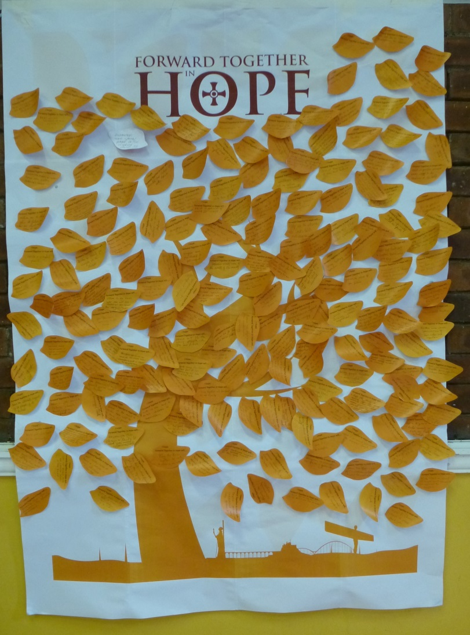
- Bring people of the parish together.
- Increase my prayerfulness.
- Work! Be successful.
- Help increase faith among Catholics.
- Be a positive experience for our parish.
- Be supported by parish priests.
- Help us look to the future.
- Provide opportunities for youth.
- Give us a vision of the future.
- Help young people.
- Strengthen parish life.
- Prepare parishioners for change.
- Ensure the future of our parish.
- Bring people together.
- Unite a prayerful parish.
- Involve more people in our parish.
- Help our community to grow.
- Make us true Disciples of Christ.
- Open church doors to all.
- Encourage our parishioners to think more about where we are going both spiritually and practically in the parish.
- Help the laity to realise their role and exercise their talents.
- Draw our neighbouring parishes together.
- Reach out to “hidden” parishioners.

- Participants were asked to indicate some of the approaches that they were already using to implement Forward Together in Hope in their parishes. Their responses are given below:

- Shown DVD during mass. Parish Councils meet to discuss questions
- Use of newsletter to ask one question per week and to receive answers in a box at the back of church. Involve our schools.
- Questionnaire (Part B) issued to Group Representatives to disseminate to members to ascertain their views. Others to be invited very soon. Part A to be issued in September.
- Sending the questionnaire to all groups in the parish.
- Multiple approaches - whole parish at homily to hear as many voices; to parish teams / groups to share their involvement / knowledge.
- A meeting invitation was extended to the whole parish, it was good for people to be given the information re number of priests.
- Parish meetings, parish audit, DVD and PowerPoint presentation at Mass. "Upper Room" food & drink for meeting, 24 hr of prayer.
- Fortnightly meetings preceded by 30 minutes prayer opportunity in church. Clear timescale; clear structure of content / task. Questions distributed every 2 weeks to Mass congregations (by the PP) box at back of church for responses.
- Have shown DVD and will invite families / groups to watch.
- Engaging with individuals, groups and schools to ask what they like / dislike, positive and negatives of the parish.
- Small groups meeting after mass to look at each question.
- Data sheets for all parishioners in advance of open meetings. Use of parish website.
- Prayer. Now going to do parish presentation and other questions for individuals to complete
- Open meetings - not well attended. Points made from the lectern and in the Parish Newsletter. The prayer card widely distributed. DVD given to anyone interested.
- Open meeting. Information and discussion sheets included with weekly parish bulletin / newsletter.
- Summarising Section A key messages in bulletin. Summarising intro to reflective questions (3 of them) in bulletin a week prior to distributing question cards in Mass to be answered instead of homily (reflective music and children's choir during this time). School chaplains running discussion group on our questionnaire. Primary school heads distributing letter from PP and questionnaire to all parents / carers.
- Prayer on newsletter and said at all Masses. Representatives of many parish groups at meetings. Visual reminders prominently around church.
- Prayer on parish bulletin. 'Open meetings'. Reps meet regularly with PP.
- Adaption of materials for local needs - breaking things up into digestible sections.
- Small group of five volunteers exploring document section by section with report back via bulletin. Reflective questions given to community.
- Drip feeding information regularly. Involving youth in schools through secondary school chaplains. Using Mass to give people a chance to input ideas into questions. Giving ideas on questionnaire to help people.
- Joint parish meetings. Inter parish social meetings.
- Drip feeding information to parishioners - giving them time to think.
- Still at the beginning. Have shared data collection between numbers of people relating to their expertise.
- Parish presentation and handing out the leaflet with the reflective questions for pondering by the congregation. Feedback meetings for parishioners to air their views.
- Display in church. Contacting parents in school.
- DVD to as many people in parish as possible, posters on pillars in church.
- Open meetings.
- Meeting after mass to watch DVD and consider questions. Booklets of questions distributed to those at meeting and available to be picked up.
- Display of prayer and logo permanently on altar. Prayer within the Bidding Prayers.
- We have a cluster group meeting with the clergy. We use the prayer at our Service of the Word and Communion.
- Questionnaire displayed at back of church. Open meetings arranged.
- Using the "homily" time.
- Q's put to parish during the homily.
- Prayer before Mass; Displaying FTiH information in church; Working as a cluster of churches.
- Parish sessions x4. Handouts / speech.
- Showing DVD, distributing flyer, identifying as many anchor groups as possible to reflect all parts of community.
- Presentation during Mass. Sub group developing data / draft ideas on responses to share and invite discussion across community.
- Prayer at beginning of Mass.
- DVD shown. Meeting with prospective member of a committee being set up and decision on those taking on positions within etc chair, scribe etc.
- Published information from parish data pack, together with summary of questions.
- Researching the approaches of other Churches. Collating and presenting to our group.
- In its infancy - small working groups formed.
- Contact with primary school - use of parent emails - approaching parents who no longer come to church. Breakdown of questions to help - in tick-box form to simplify and stimulate ideas.
- Broken it down to about 8 sections. Simplified the questions. Added background to the questions each time.
- Questioning / listening to groups who don't come to church, people identified to talk to young people / lapsed Catholics. Opportunities for information gathering 'suggestion' box, identify key people as points of contact for those who don't attend meetings / church.
- We have a small group collating information and then having 'open' meetings to present and discuss FTiH.
- Vigils of prayer. Individual communication.
- Small groups. Discussion through mass and schools.
- Put up posters around the church showing pages from FTiH folder.
- Sharing data and displays. Formation of small working groups to start data gathering.
- Shared the Anchor leaflets at the beginning of May.
- Adoration of Blessed Sacrament weekly. Come as living stones - prayer liturgy. Waiting for holding crosses to give out to housebound. Anchorites with priest and small group of parishioners.
- Displays in church hall using some of the information from the pack. Putting the questions on the Newsletter - timely for the meetings to give people the chance to think about it.

- Participants were asked to record any other comments or ideas.

- Could we have such meetings on a regular basis?
- A theology of hope.
- Greater use of new technology for younger people.
- SVP having discussions with housebound.
- Need a mechanism to tip the balance to involve more young people in order to share their views, needs and hopes.
- Very impressed by the plan to have 24 hour prayer vigil!
- Please help people whose parish priests are apathetic or obstructive.
- Pray, pray and pray
- An expansion of the analysis of how Catholic Church works structurally which helps to see where conflict points may arise with Forward Together in Hope process.
- I'm struggling with squaring the spiritual message with the business-like change management approach. I think that although it is being extremely well managed by the team it raises antibodies with parishioners.
- Make data information simple to focus on the decline in commitment.
- Relaxed atmosphere gives confidence to participate.
- Working together with another lay representative.
- Questions for schools.
- Better together - bring in the other churches.
- Approach Holy Communion and Confirmation parents.
- As with much of the education offered by the Diocese this has been very Newcastle centric. I'm pleased to see you are going to use Deaneries Sept-Oct.
- Thank you for FTH.
- How can all of these ideas put forward (some of which I couldn't hear) online to be shared by all?
- Weekly email of best practice / ideas.
- How do you deal with the priest who is disengaged? Also need to acknowledge the aged people of the parishioners who don't use technology.
- Please make good practice ideas available to share.
- Some communities have found the Questionnaire quite daunting so have broken it down with a couple of questions on a card for people to take away and think about before coming to more general meetings to explore their approaches to them.
- When we have our 2 meetings to discuss the Qs we will have a PPC member in each discussion group to collate answers. The PPC was asked to complete the missing data. Could a member of the Team visit the parish just before the meeting(s)? The Head teacher(s) should be encouraged to speak at Mass about how the Forward Together in Hope process is being rolled out in school(s).

Questions and Responses
A number of questions were asked ‘from the floor’ with others being posed on feedback sheets. The questions and responses are presented here.
- Forward Together in Hope is all about change. How can we grasp the extent of this change?

The basic change that matters is that possible within each of us as we discover how to become better witnesses to Jesus in our world today. We are called to be disciples in a changing world and a changing Church. One of the changes in our Church is in relation to the number of Catholics who worship in our Diocese. Thirty years ago there were around 100,000 people worshipping in our churches each weekend. Last year there were 36,500. That is a decrease of almost two thirds in 30 years. At the present moment we have 103 active priests in our diocese in over 170 parishes. We estimate that in 15 years’ time, in 2030, we will have 50 active parish priests in the Diocese, less than half the number we have now. We need to think very seriously how we can ensure that our worshipping communities are viable and flourishing in the future so that we can continue to discover how to be dedicated disciples of Jesus.
Cardinal Hume used to have a phrase: ‘When someone says; ‘Something has to change around here’, I get worried, because what it really means is, I have to change’. There is a danger that when we say something has to change we presume that it will happen out there, someone else will have to do something about it. In reality is means that every one of us will have to gradually see things differently, do different things with our time, build relationships with new people. It is never easy, but as someone once said: ‘To live is to change and to be perfect is to change often’.
- If everyone is inputting their questionnaires on line, how can the FTiH Team ensure that the system will not crash?

We decided in April last year (2014) that we would use the Questionnaire format to invite every Catholic to participate in discussion about our Church today and in the future. More recently we have been working with Karen Kilby, the Bede Professor of Theology in Durham University, and one of her colleagues, Mathew Guest, a Sociologist of Religion, to assist us in the format of the Questionnaire and in ways to analyse the results. They advise us that the Bristol Online Survey will adequately serve our needs and they have used this provider on previous occasions for surveys and research work. It has been used by other Departments of Durham University. It has a good track record in dealing with questionnaires like ours and we trust that it will do what we want it to do!

- What if we cannot find anyone in the parish who will input via the on-line questionnaire?

One of the things that is happening in some parts of the Diocese is that people are volunteering to help with Forward Together in Hope who have never offered to do anything in the past. It may well be that there actually is someone in the community who can manage electronic communication, and a call out to someone to spend a couple of hours later in the year might reveal someone to assist.
It may well be that there will be someone in a neighbouring parish who could help.
At the end of the day, no one need worry, if there is a problem, then get in touch with the FTiH Team and we will find a way of helping to have it completed. The absolute last resort will be to use paper!
- If all the answers to the Questionnaire have been typed up in Word, does this mean that it will have to be re-typed again on line?

If the information has been collated into a Word version of the Questionnaire, you can use the cut and paste facility so that the text will not require retyping.
- Can the questions in the Reflective part of the Questionnaire – part B – be more than 250 words?

It is a fairly comprehensive questionnaire, and there are over 170 submissions to be analysed. We decided that there was a real danger that analysis would be just impossible if the responses were too long, so they are restricted to 250 words. It is possible to use bullet points to catch as many responses and observations as possible. There is no restriction on Part C of the Questionnaire (page 45) on the Community’s Initial Thoughts and Ideas about the Future, or in response to the request for example of Good Practice (Question12 on page 44).
- Why did the Bishop decide on Forward Together in HOPE, rather than Faith or Charity?
There was a good deal of discussion at the Bishop’s Council away-days in January this year about the title. Some of the discussion focussed on how we are all called to each of the virtues but that Hope is the one we understand least! It is the virtue which invites us all to wonder about the future, wonder how the Spirit will guide us in the future and ensures that we have confidence that the Lord is indeed with us always, even to the end of time. It is very different from ‘Optimism,’ – which is really a desire for what we want to happen. Hope is a statement of faith that the God who loves us will guide us in the right direction.
Incidentally, the Philosopher Kierkeguaard once said: ‘Hope is only a virtue in a hopeless situation’. The situation we’re in isn’t hopeless – but there’s something delightfully risky and faithful in what he says.
- Why are Deans not more proactive in providing support for parishes?

There may be a feeling around that when a Bishop wants something to happen then he lets the Deans know and they then let the priests know and then it happens! It doesn’t quite work like that! In many ways each parish has a great deal of independence. The Church is most effective in each locality, and each locality is different. It is not the case that ‘HQ of the Church’ is in the Vatican and then everything flows from there – each parish is a community of people who love God and neighbour in their area. The Bishop is the focus of unity of the Church in each Diocese.

Having said that, all the Deans in the Diocese have been contacted and meetings are being arranged at Deanery level between early September and mid-October. Either Tony or Jim will facilitate them (or both if they’re both available) and every priest, lay representative, school and other interested parties will be able to attend.
- How do we get those not worshipping back to Mass?
Anyone who can answer this one will make a fortune! Some communities are approaching school chaplains and asking them to approach the parents of children who attend the school to look at the Questionnaire from their point of view. Some communities are asking people to mingle with those who bring children to school and explore with them how they feel about the church.
In the near future we will be releasing a very short questionnaire which we hope will find its way into the hands of people who no longer worship – among others. It will be an electronic exercise, and hopefully we will be able to discover some of the reasons why so many people have ceased to worship in our communities. It may be that we have to humbly engage in some reflection on why people choose not to worship with us. Cardinal Casper once said: ‘For it is not enough to tell, what is wrong with them, we have to ask what is wrong or what is deficient with our own pastoral work? Why do so many Christians leave our Church? What are they missing with us and searching elsewhere?’
- Is it possible to have more meetings like this?

It certainly is, but perhaps we need to sense the lie of the land during our Deanery meetings later in September/October and see what Parish Representatives need then.
- What can we do about ‘Apathy’ – a Lay Representative requested people to stay behind after mass and very few did.
Quite honestly, we can only do the best we can! Some priests are using the homily time during mass to invite people to respond to the pre-printed questions on cards, or have invited people to take away a couple of questions that will be explored the following week. It’s important for us to remember that this may be the first time that regular mass goers have been invited to participate in a diocesan wide discussion, so it is not too surprising that some find it ‘unusual’. It is perhaps worth adding that the small group that met did produce 6 pages of reflections and the whole parish has been invited to respond to them.

Forward Together in Hope Team
August 2015

